International Partnering Associates

Experiencing Partnering

Work Book & Journal

V 2.1 © IPA, 2013

Introduction to the Workshop
This training workshop has been developed out of the experience of an organisation called International Partnering Associates, known generally as IPA.
IPA is a network of people, who work with different organisations, ministries and churches, and who have in common a passion to see organisations and ministries work together in partnerships to impact the work of Christian mission and ministry.
The approach we will be taking in this workshop comes out of IPA members’ experience of developing actual partnerships among Christian ministries over the last 20 years or more. Most of these partnerships were focused on evangelism and church planting among largely un-reached people groups in Africa, Asia and the Middle East. However, this model has been used successfully in many other contexts beyond impacting unreached people groups.
The curriculum for this workshop has been developed by an international team of three partnering people, all with more than 60 years of partnering experience between them. This explains why in some cases you will find American spelling and in others English spelling!

Contents of the Workbook:
Session |  |  | Page
1 | Building a Foundation for Partnering: An Introduction |  | 3
2 | Building a Foundation for Partnering: Why Work Together |  | 4
3 | The Partnering Process: Participation and Communication |  | 5
4 | Building a Foundation for Partnering: The Heart of God 1 |  | 6
5 | Building a Foundation for Partnering: Ways of Working Together |  | 7
6 | The Partnering Journey: Getting our Bearings |  | 10
7 | The Partnering Process: Building Consensus |  | 11
8 | The Partnering Journey: Awakening |  | 12
9 | The Partnering Process: Getting to Success |  | 13
10 | Building a Foundation for Partnering: The Heart of God 2 |  | 14
11 | The Partnering Journey: Preparing |  | 15
12 | The Partnering Journey: Exploring 1 |  | 19
13 | The Partnering Journey: Exploring 2 |  | 22
14 | The Partnering Journey: From Exploring to Forming |  | 23
15 | The Partnering Journey: Consensus in the Forming Process 1 |  | 25
16 | Building a Foundation for Partnering: The Heart of God 3 |  | 26
17 | The Partnering Journey: Consensus in the Forming Process 2 |  | 27
18 | The Partnering Journey: Getting People Together |  | 31
19 | The Partnering Process: Demonstrating what we have learned |  | 34
20 | Building a Foundation for Partnering: The Heart of God 4 |  | 35
21 | The Partnering Process: Building and Breaking Trust |  | 36
22 | The Partnering Journey: From Passion to Action |  | 38
23 | The Partnering Journey: Continuing On |  | 41

Session 1: Building a Foundation for Partnering
PURPOSE OF THE WORKSHOP:
A guided experience in community designed to help you increase your competence, capacity, confidence, commitment and passion to engage in partnering to carry out your part in the mission of God.

LEARNING OUTCOMES FOR THE WORKSHOP:
By the end of this workshop you will be able to
- Describe God’s heart for relationships, unity and working together in the Body of Christ
- Explain your passion and vision for a specific ministry, and how partnering can help achieve your vision
- Create a positive environment for partnering in your context
- Determine what needs to be done to start or strengthen a partnership to achieve your vision
- Describe the phases in the partnering journey and identify where you are on that journey
- Apply the strengths of a consensus-based approach to the partnership you are envisioning
- Describe how you need to grow and change to be a more effective partner

JOURNALING EXERCISE
Take the three learning outcomes that you have selected as being most important for you, and re-write them here using the first person:
By the end of this workshop I want to be able to:

Session 2: Building a Foundation for Partnering:
Why Work Together?

EXERCISE 2a:
You are about to meet with a group of Christian leaders in your city who aren't convinced of the value of working together. How would you motivate them to think differently about working together?

Discuss in your groups.

EXERCISE 2b:
Read Acts 15:36 to the end of Acts 16.
In groups discuss the following:
- Imagine you are telling the story of how the church in Philippi started. What are the most interesting and important things you would include?

- How do you see God at work in all this?

- What experiences did God take Paul through that resulted in such a deep relationship between Paul and the church in Philippi?

- What do you notice about the composition and diversity of the young church in Philippi?

JOURNALING EXERCISE
What do you think are the most convincing reasons for working together in the Body of Christ?

What do you sense God is saying to you about partnering?

Session 3: The Partnering Process:
Participation and Communication

JOURNALING EXERCISE
What have you learned in the exercise and in the de-briefing that could help you be more effective in a specific partnering situation in which you are already involved or in one you hope to start?

Session 4: Building a Foundation for Partnering:
The Heart of God 1

The Bible passage for today is Philippians Chapter 1 and the focus is on relationships in the body of Christ and how it relates to God’s Heart for relationships, unity and working together in the letter to the Philippians

EXERCISE 4a:
Individually read Philippians 1 and reflect on the following questions
- Verses 3-8: We often think of Paul as a forceful, hard-driving person. What does this passage reveal about his capacity for caring for others?

- Paul gives a full report of his situation to the Philippians in this introductory section of his letter. How do you think this strengthened his relationship with them?

- Verses 23-26: Think about your own relationships. Do you know people like Paul, who are motivated to spend time with you so that your joy in Christ will overflow? Describe the impact that people like this have had on your life. How could you become more like this yourself?

- Think about any specific ministry relationships that are particularly joyful or difficult for you. What light does this passage shed on these relationships?

EXERCISE 4b:
For discussion in your groups:
What does the theme of relationships in the body of Christ in Philippians Chapter 1 reveal to us about God’s Heart for relationships, unity and working together?”

JOURNALING EXERCISE
What is God saying to you about the quality of your relationships in your partnering context?
Session 5: Building a Foundation for Partnering:
Ways of Working Together

SCENARIO 1:
Six months ago Ramez and Maria moved into a neighborhood in Buenos Aires to minister to street children. Since arriving, they have discovered at least five different Christian groups working in the same neighborhood. Maria is alarmed that these ministries never get together to talk. But Ramez is very focused on carrying out the ministry God has called them to do among the street children, and doesn't want to be distracted by meeting with other ministries. “Why waste our precious time in meetings when there is so much to do for these kids?”

Maria finally convinces Ramez that their work with street children could be more effective if they knew what these other ministries were doing. They decide to organize a meeting at a local coffee shop to encourage ministry leaders to come together and talk about their work.

This meeting is so successful that the group decides to start meeting quarterly. They have continued to meet regularly in that same coffee shop for the last two years to update each other on their ministries.

SCENARIO 2:
There are only 50 known believers in a large unreached people group in West Africa with several million people spread over four different countries. At least ten ministries have been working among them for decades, but with little impact. At the funeral of a well-respected Christian leader several years ago, leaders from three of these ministries, Kofi, Andrew and Sara, met for the first time and discovered they all had work among this large people group. They began to meet and look for ways to work together. They also decided to draw in the other ministry leaders working in the same group. After almost a year of one-on-one and small group conversations, seven of the ministries met together to share their vision for reaching this people group. They identified two projects which they worked on together over the next 12 months. At the end of that time, they evaluated their progress and agreed to take on two bigger projects together for the coming year. At that time, another agency decided to join their efforts.

SCENARIO 3:
In March 2001, 320 delegates from 36 African nations met in Jerusalem for the African Millennial Consultation. Recognizing that the AD 2000 and Beyond Movement was in the process of disbanding, and that there yet remained much to be done, the participants determined to establish a continuing African movement. Participants unanimously affirmed their commitment to pick up the torch for national and global evangelization. Thus the Movement for African National Initiatives (MANI) was birthed out of the closure of the AD 2000 and Beyond Movement.

MANI is a network of networks focused on catalyzing African National Initiatives and mobilizing the resources of the Body of Christ in Africa for the fulfillment of the Great Commission.

The purpose of MANI is to affirm, motivate, mobilize and network Christian leaders by inspiring them with the vision of reaching the unreached and least evangelized in Africa, and the wider world, through the communication of up-to-date research, reports and models; consultations and prayer efforts focusing on the unfinished task.

EXERCISE 5:
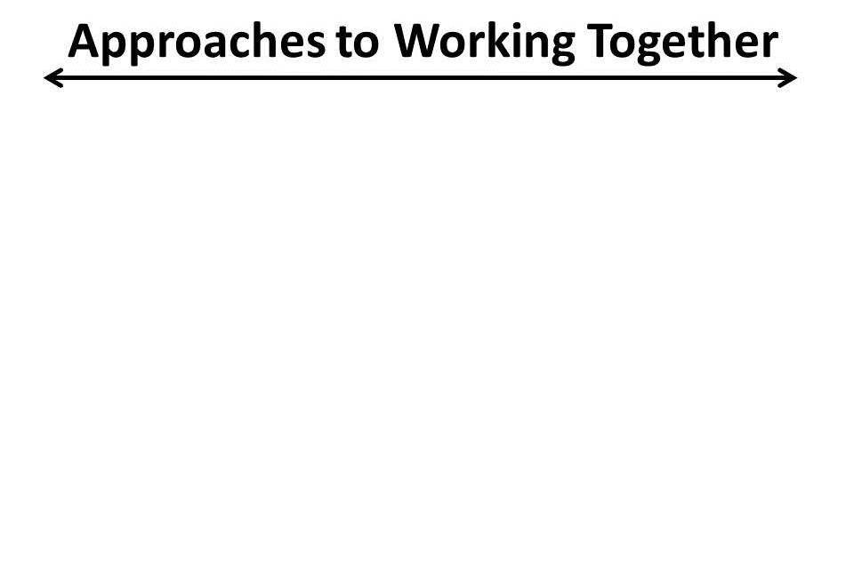
JOURNALING EXERCISE
In light of what you have learned about the differences between networks and partnerships, focus on at least one of the following questions and record your observations:

Why is it so important to have a clear and compelling vision for a partnership?

How much complexity (a few partners or many partners) will be needed to best fulfill your partnering vision?

How much diversity (similar ministries or diverse ministries) will be needed to best fulfill your partnering vision?

Session 6: The Partnering Journey: Getting our Bearings

JOURNALING EXERCISE
Think about the partnership that you are focusing on for this workshop, where are you on the partnering journey?

What has helped get you there?

Session 7: Building Consensus

JOURNALING EXERCISE
How did you respond to this method of reaching consensus?

Where might you be able to use this method for yourself?

Session 8: The Partnering Journey: Awakening

EXERCISE 8a:
Imagine that you are Nehemiah, and that you've been asked to express your passion in a short statement. Now write your passion statement for Nehemiah beginning with “I (Nehemiah) have a passion to....

EXERCISE 8b:
Record any words or phrases that God might be showing you (either clearly or through hints and ideas) about partnering which might heop you to describe your own passion for partnering in a ministry setting.

EXERCISE 8c:
Using ideas and thoughts from Exercise 8b, write a first draft of your personal Passion Statement here: "I ................... have a passion to...

JOURNALING EXERCISE
Write the final version of your personal Passion Statement here:

Imagine that your personal passion has been fulfilled. What would that look like? What in the world would be different if your passion was fulfilled?

Session 9:
The Partnering Process: Getting to Success

EXERCISE 9a:
The purpose of this exercise is for you to end up with a positive score
Score Sheet:
ROUND | GROUP 1 Colour | SCORE | GROUP 2 Colour | SCORE | GROUP 3 Colour | SCORE | GROUP 4 Colour | SCORE
1
2
3
4
Consultation Opportunity (Score -2)
Sub-Totals:
5
6
7
8
Consultation Opportunity (Score -2)
Sub-Totals:
9
10
TOTAL SCORE

One group chooses blue +6 Three groups choose red -6 each
Two groups choose blue +2 each Two groups choose red -2 each
Three groups choose blue +4 each One group chooses red -4
All groups choose blue -3 each All groups choose red +4 each

Before Round 5 and Round 9 each group can appoint a representative to consult and negotiate tactics with representatives from the other groups. This can take place even if one or more groups do not want to take part. Because there is a cost associated with attending a Consultation, any group that chooses to attend the Consultation will be debited 2 points

Rounds 9 and 10 count double e.g. if your group chooses blue and all others choose red you will score +12, they will each score –12.

JOURNALING EXERCISE
What did you personally learn about working together – or not working together – from this exercise?

Session 10: Building a Foundation for Partnering:
The Heart of God 2

The Bible passage for today is Philippians Chapter 2: 1-18 and the focus is on humility and how it relates to God’s Heart for relationships, unity and working together in the letter to the Philippians

EXERCISE 10a:
Individually read Philippians 2:1-18 and reflect on the following questions
- Verses 2-3: What relationship do you see between humility and our ability to be one in spirit and purpose with others?

- Verse 4: Imagine that even a single partner in a partnership followed Paul’s instructions in this verse. What impact would that have on relationships within the partnership?

- Verses 6-11: What do you find most wonderful or amazing about how Jesus humbled himself?

- Verses 6-8: In obedience to the Father, Jesus let go of his position and privileges and humbled himself to fulfill God’s purposes for his life and death. How difficult is it for you to let go of your position or privileges in order to work together in unity with others in the Body of Christ?

EXERCISE 10b:
For discussion in your groups:
What does the theme of humility in Philippians Chapter 2 reveal to us about God’s Heart for relationships, unity and working together?”

JOURNALING EXERCISE
What is God saying to you about humility in your partnering efforts?

Session 11: The Partnering Journey: Preparing

A Reminder of the Purpose of this Workshop:
A guided experience in community designed to help you increase your competence, capacity, confidence, commitment and passion to engage in partnering to carry out your part in the mission of God.

Champions start partnering around an overwhelming need that is too important to ignore and too big to address alone

A CASE STUDY
Luke (not his real name) had been a strong teen-age leader of a military rebel group in South East Asia known for trying to de-stabilize the national government. Through a set of miraculous events, he became a follower of Jesus.
He became a very strong witness of Jesus among his own people group and soon developed a small congregation of MBBs (Muslim Background Believers). But he felt limited by the smallness of his group and the large UPG (Unreached People Group) that needed to be reached.
Luke went through an introductory partnering course offered by IPA and wanted very much to begin a partnership to reach his people group.
A 4-day partnering formation meeting was held with a dozen organisations and churches involved. Luke was the inspirational facilitator of that forming meeting and the group chose him to be their partnership facilitator. Funding was processed through his church.
However, in the coming months most of the initial partners left because they felt Luke was overbearing and told everyone what to do. He became very discouraged and negative about the former partners and about partnering.
For about 3 years nothing much happened in the partnership. During this time, Luke and his family were the targets of a foiled assassination plot. Luke continued working on his own, mostly through his church.
Even though most Christian leaders said Luke was too strong and overbearing to work with, another partnering facilitator saw his potential and began to spend time mentoring him.
Over the next few years Luke also attended several more partnering trainings. He began to become less forceful and more gentle as a leader and actually admitted that he was too dictatorial. He introduced more interactive approaches in his work, and began talking to pastors and a few agency leaders about reviving the partnership.
Soon a small a group of former partners met to see about working together again. Another facilitator led the re-formation meeting, and Luke seemed more relaxed about what was being decided. A partnership bank account was set-up to channel funds on which others were signatories, but not Luke.
He was again chosen to be the facilitator for the partnership, but this time as part of a facilitation team. Even though this partnership does not have as many partners now, there is a great sense of shared ownership among the partners and the partnership itself has greater credibility, which has attracted some new partners.

EXERCISE 11a:
- What strengths do we see in Luke as he takes on this challenge?

- What did he need to learn before he could begin to build a more successful partnering effort?

- What changes did he need to make in his own life so he could take on this challenge?

- In what ways can you identify with Luke? How similar or different has your own approach to partnering been to his?

- What could the partners have learned through this process?

- How do you see God’s hand at work through this journey?

EXERCISE 11b: Assessing Our Readiness to Partner with others:

A. Personal Readiness  Write short phrases to describe:  1. Personal Partnering Strengths that you already have  2. Things to Learn or Change personally in order to partner well | B. Church, Ministry or Agency Readiness  Write short phrases to describe:  1. Partnering Strengths that your church, ministry or agency already has  2. Things your church, ministry or agency needs to Learn or Change in order to partner well
C. What two or three Personal Action Steps will you take in the next 90 days to help you be more ready to partner well?

JOURNALING EXERCISE
Record what you sense God is saying to you about the things you need to learn and the changes you need to make to be a better partner?

What kind of help and support will you need from God and others to carry out your action steps?

What might God be saying to you about how you could help your church, ministry or agency to change?

Session 12: The Partnering Journey: Exploring 1

ZABRONI PEOPLE PROFILE
The Zabroni people are one of several minority groups living in the Republic of Udon. They are nominally Muslim, with deeply rooted animist beliefs. The latest official population figures for the Republic of Udon indicate that there are approaching 300,000 Zabroni in the country.
The Zabroni are subsistence farmers concentrated in the mountainous north-western area of the country. This region has historically been neglected by the government, because of difficulty accessing the region. Health-care facilities are poor; infant mortality is a major challenge. Although primary education has been relatively good, there are limited opportunities for secondary education in the region. A small number of young Zabroni have migrated to Udon City, the capital of the country, for education and employment.
The President of Udon recently initiated a new road-building project in the region to enable better access to the newly discovered rich mineral and coal deposits there. He is keen to encourage groups who want to help develop the economy of the region. The Ministry of Communication has recently announced that they will establish a string of community radio stations across the country.
In the past, several different agencies tried to start work among the Zabroni, but no workers are present in the community today, and there are no known believers. However, some of the younger Zabroni who have migrated to the capital city have shown interest in the Gospel through the witness of Udonese friends. There is a small but growing church among the neighboring Barzi people.

EXERCISE 12a: Developing a Partnering Vision
GEOGRAPHICAL FOCUS  city(ies), state(s) or territory(ies), nation | PEOPLE / PEOPLE GROUP IN FOCUS
My MINISTRY PASSION (from Session 09) explained in words:

My MINISTRY PASSION (from Session 09) illustrated in pictures:

How can my MINISTRY PASSION be fulfilled more effectively through partnering? explained in words:

How can my MINISTRY PASSION be fulfilled more effectively through partnering? illustrated in pictures:

BUILDING TRUST IN THE EXPLORING PHASE OF THE PARTNERING JOURNEY

As a partnering champion two signs that you can look for to tell whether you have done an effective job of building trust during the Exploring Phase are:

“Have you helped potential partners have confidence and hope in the process and benefits of partnering itself?”

“Have you helped potential partners have confidence and hope in working with others whom they would not normally have trusted or chosen to work with.”

We can call this “building working-level trust” among the potential partners – building enough trust to enable them to believe it would be worth the effort to work together.

JOURNALING EXERCISE
- Who are the first two or three potential partners that I want to meet with?

- What are the most important things that I need to learn from then?

- What are the most important things I need to learn from these one-on-one meetings?

- What actions do I need to do after each of these meetings?

Session 13: The Partnering Journey: Exploring 2

JOURNALING EXERCISE
What are the main points of the vision that I want to communicate in my one-on-one meetings?

What have I learned here that will enable me to be a better partnering champion?

Session 14: The Partnering Journey:
From Exploring to Forming

CASE STUDY:
Joe Fridella of “Envision 28:19” Mission has been meeting with a number of different people who he has identified as wanting to reach the Zabroni people with the gospel. He has been building relationships with them and sharing with them a vision for reaching the Zabroni people together in a partnering approach.

He’s been encouraged by his meetings with a number of people who have indicated that they would be willing to attend a meeting to talk with others about how they might work together and what they might do together. Although there were a few people who said they weren’t interested in what they described as “wasting time” in meeting with others, he feels that the time is probably right to bring those who are interested together in a meeting.

He mentioned to his wife that he was thinking about sending an e-mail to the folk who had said they were interested in meeting together in a couple of weeks at their mission headquarters. It was then that his wife reminded him about what they had learned at the “Experiencing Partnering” Workshop they had attended before coming to Udon. She reminded him that there were a number of important elements that they needed to think about as they planned the meeting and that maybe he should re-think some of his plans.

EXERCISE 14a:
1. Who should be invited?

2. Who should send out the invitations and how should they be sent?

3. Who should chair the meeting and facilitate the discussions?

4. How do you set the dates for the meeting & what advance notice should be given?

5. Where should the meeting be held and the use of the meeting space?

6. What are the financial implications of holding this meeting?

EXERCISE 14b:
What are some of the “Building Blocks” that should be included in the meeting?

JOURNALING EXERCISE
As you think about the partnering initiative that you are envisioning reflect on one or more of the following questions:
Who should you invite to the meeting?

Who would be the best person/persons to send out the invitations?

Who would be best suited to facilitate the meeting?

What issues do you need to think through about when to hold the meeting and how much notice should be given?

What issues are there about where the meeting will be held?

What are the financial implications of holding this meeting?

What are the Building Blocks you will include in the meeting?

Session 15: The Partnering Journey:
Consensus in the Forming Process 1

Note:
- The Process of Consensus is as important as the decision

- The Goal of Consensus is making decisions everyone supports and will (help) implement

Session 16: Building a Foundation for Partnering:
The Heart of God 3

The Bible passage for today is Philippians and the focus is on sharing together in ministry through generosity and gratefulness and how it relates to God’s Heart for relationships, unity and working together in the letter to the Philippians.

EXERCISE 16a:
Individually read Philippians 4: 14-16 and also think back to how the church in Philippi started (Acts 15:36 to the end of Acts 16) and then reflect on the following questions:

- What does their generous support of Paul reveal to us about God’s Heart for relationships, unity and working together in the Body of Christ?

- What kind of bond developed between them?

JOURNALING EXERCISE
What is God saying to you about generosity and gratefulness in your partnering relationships?

Session 17: The Partnering Journey:
Consensus in the Forming Process 2

CASE STUDY: BUILDING CONSENSUS IN A MEETING TO DISCUSS A POSSIBLE PARTNERING INITIATIVE TO REACH THE ZABRONI PEOPLE

From Joe Fridola to his supervisor…

You asked me how we came to agree on which were the most important priority needs in our meeting to discuss a possible partnering initiative among the Zabroni people.

After a number of discussions on the Zabroni, and on hearing reports from each of the ministries and churches attending the meeting, we agreed that we could address the following issues:

- Education and Economy: Secondary education opportunities are very limited in the Zabroni homeland. Young people are moving to the capital to look for work, but they have no skills. They are more open to the gospel. The government is interested in economic development in rural areas, and is investing in roads to increase the people’s access to the capital city.

- Spiritual bondage: Occult practices are strong in the homeland. This creates a great deal of fear, and an unwillingness to change the way things have always been done, which increases people’s resistance to the gospel.

- Health: Most Zabroni don’t have access to clean drinking water. Infant mortality and maternal mortality rates are very high. Medical facilities are either non-existent or poorly staffed and maintained. Many Zabroni are afraid to use medical facilities.

- Orality, language and literature: The Zabroni people have a very strong oral story-telling tradition, but much of it is being lost because the stories haven’t been written down or recorded. The Zabroni language is unwritten; there are no books. The government wants to establish radio stations throughout the country.

I asked everyone to think about the next 12 months, and what God might want to do to create a breakthrough among the Zabroni people.

And then I asked the following question, which I called “The Consensus Question”, because it would help us agree on which activities we could work on together over the next year or so:

What could we do together over the next 12 months which would have the greatest impact in meeting these needs of the Zabroni people in a way that honors God?

Then I got everyone listing their ideas on separate Post-It Notes and after about 5 minutes, got everyone into small groups to share what they had come up and agree together on no more than five ideas to share with everyone else.

We took about 20 minutes for this part of the process, and then each group shared what they had come up with. We had quite a list!

The ideas they came up with were:
- Establish a secondary school in the Zabroni homeland
- Establish a hostel for young Zabroni’s looking for work in the capital
- Establish an agricultural centre to provide work for Zabroni
- Recruit road engineers to help the government with the road improvement scheme
- Create a prayer resource to encourage prayer for the Zabroni people and for work amongst them
- Establish a mobile clinic to help with health care in the Zabroni homeland
- Recruit midwives to work in the Zabroni homeland
- Build a hospital in the city
- Begin a simple water project to enable the Zabroni to filter water for themselves
- Distribute bottled water
- Begin a training programme to train Zabroni in simple medical procedures
- Begin a Bible Translation Project
- Translate and record Luke’s Gospel and distribute it
- Set up a community FM radio station in the Zabroni homeland
- Translate Bible stories from the Old Testament and from the Gospels
- Send a team into Zabroni land to live among the people for a year or two and to work with community leaders to identify specific challenges and opportunities that are of critical importance to them

EXERCISE 17a: Building Consensus in the Forming Process

Work through the following scenario in your group:

Imagine that you were present at that meeting to consider possible partnering activities for the Zabroni people.

- You have each been given three votes to allocate to one or more of the ideas that emerged in the meeting.
- Individually decide how you would allocate your three votes.
- Share in your small group how each of you allocated your votes
- List all the ideas that received more than two votes from your group
- Then repeat the process again. Individually decide how you would allocate your three votes
- Share in your group how each of you would have allocated your votes
- What are the top two, three or four ideas favoured by the most people in your group?

HOW TO COME TO AGREEMENT THROUGH A CONSENSUS APPROACH OVER (OR REGARDING) DIFFERENT PRIORITIES:
Take some time to
- discuss the big picture of the project or people that you want to reach through partnering
- discuss ministry activities which have been used in the past (both those that have had impact and those that have not)
- Have each ministry, organisation and church report on their current and planned work
- Pray, pray more, and pray even more!
- Agree what those at the meeting think are the priority needs that need to be addressed and list them

Then follow these steps:
- Ask the question: What could we do together over the next 12 months which would have the greatest impact in meeting these needs in a way that honors God?
- Give people 5 minutes to think individually about the question and to write down at least three ideas as a response to that question on A5 paper
- Form small groups of 4 - 6 people. Allow 20–30 minutes for each group to
  - Share with each other what they have listed
  - Gather similar ideas together into clusters
  - Summarize what’s similar about the ideas in each cluster in a word of phrase and write it on top of an A4 sheet and attach the A5 pages that relate to that cluster to that sheet
  - Continue clustering similar ideas in the same way – there is no limit to the number of clusters each working group can come up with
- Ask someone from each group to report to the whole group about their cluster lists, identifying each one as they put it up on the wall, making any explanation necessary.
- Gather together similar clusters from each of the small groups
- You now need to prioritize the clusters you have grouped so that the whole group can identify what together they sense are the most important / do-able actions they can take together over the next 12 months (you don’t want projects that are too complex when you begin to work together – you want some “quick wins”). Do this by saying something like Take a minute to look at the combined clusters on the wall. Which ones do you think will help us address some of the most important needs we have already identified. Then use a prioritizing process to determine which of the clusters could be the focus for the next 12 months. (Some different ways to agree priorities are outlined below)
- Once you have agreed two or three priorities to work on then form new groups to begin to work together on ways to meet the needs that have been identified through the clustering process. It is very important that you do this and get commitment from potential partners before they leave the meeting, otherwise things might not be taken forward.

Prioritizing Processes
If you decide to use some form of prioritizing process to help determine which of the clusters the participants feel are priorities that they can do something about to meet the needs identified, there are a number of different ways in which you can get people to “vote” or indicate their preferences. For each of the following options, tell people the number of “votes” they have which they can distribute among the clusters they wish to “vote” for:

  - Go through the list of suggested clusters, with people indicating their preferences by a show of hands and record their preferences against the cluster description

  - Secretly, in which you ask people to record on paper the clusters they would prioritize. (For this to be successful, you will need to number the clusters and give people a number of pieces of paper according to how many preferences you will give them. Place one number of the cluster you prioritize on each of the papers you have been given. – this makes the counting easier)

  - Give people an appropriate number of stickers, which they distribute among the clusters they wish to select for prioritization

JOURNALING EXERCISE
Explain why using a consensus-building process is important in helping potential partners to reach agreement on priority issues.

Why is it important to phrase the consensus question so carefully?

How confident are you that you could facilitate a consensus-building process like the one used in this exercise?

If you’re not confident, what could you do to build your confidence?

When is the next opportunity you might have to practice using this process?

Session 18: The Partnering Journey: Getting People Together

EXERCISE 18a: Designing a Creative Partnership Formation Plan
- Is the purpose of the meeting stated simply and clearly? How well is the plan for the meeting designed to help the participants fulfill the purpose for the meeting?

- Is the Partnership Formation Plan clear? Will others who see your plan understand what you are trying to accomplish and how you are going to accomplish it?

- Is it concrete? Have you specified what you will do, when you will do it, how many days it will take, who will do what, and how the different activities will be done? Could anyone could pick up your plan and follow it?

- Is it compelling? Will those who you invite to the meeting find it relevant, interesting, and worth participating in?

- Is it creative? Have you been innovative in combining all of the essential meeting elements together so that they build on each other and keep the attention and interest of the participants?

EXERCISE 18b(1): Reviewing Partnership Formation Plans (1)
- Is the purpose of the meeting stated simply and clearly? How well is the plan for the meeting designed to help the participants fulfill the purpose for the meeting?

- Is the Partnership Formation Plan clear? Will others who see your plan understand what you are trying to accomplish and how you are going to accomplish it?

- Is it concrete? Have you specified what you will do, when you will do it, how many days it will take, who will do what, and how the different activities will be done? Could anyone could pick up your plan and follow it?

- Is it compelling? Will those who you invite to the meeting find it relevant, interesting, and worth participating in?

- Is it creative? Have you been innovative in combining all of the essential meeting elements together so that they build on each other and keep the attention and interest of the participants?

EXERCISE 18b(2): Reviewing Partnership Formation Plans (2)
- Is the purpose of the meeting stated simply and clearly? How well is the plan for the meeting designed to help the participants fulfill the purpose for the meeting?

- Is the Partnership Formation Plan clear? Will others who see your plan understand what you are trying to accomplish and how you are going to accomplish it?

- Is it concrete? Have you specified what you will do, when you will do it, how many days it will take, who will do what, and how the different activities will be done? Could anyone could pick up your plan and follow it?

- Is it compelling? Will those who you invite to the meeting find it relevant, interesting, and worth participating in?

- Is it creative? Have you been innovative in combining all of the essential meeting elements together so that they build on each other and keep the attention and interest of the participants?

JOURNALING EXERCISE
Having received feedback on your plan, for your partnership formation meeting for your partnering vision, what changes do you need to make?

Record your revised plan for your partnership formation meeting.

How confident do you feel about your plan for a partnership formation meeting for your partnering vision?

Who else do you want to share your plan with back in your ministry context?

What have you learned that will help you in planning other such events?

Session 19: The Challenge of Partnering
Demonstrating what we have learned

JOURNALING EXERCISE
Reflect on your part in what happened in this exercise.
How satisfied are you with the role you played?

If you had to do the exercise again, what would you do?

Session 20: Building a Foundation for Partnering:
The Heart of God 4

The Bible passage for today is Philippians 1:3-11 and Philippians 4:4-10 and the focus is on prayer and how it relates to God’s Heart for relationships, unity and working together in the letter to the Philippians

EXERCISE 20a:
Individually read Philippians 1:3-11 and Philippians 4:4-10 and reflect on the following questions
- Chapter 1:3-8: In his first prayer, Paul focuses on his relationship to the Philippians. What inspires him to pray as he does? What if you knew that someone as busy and important as Paul was regularly praying that prayer for you? What impact would it have on you?

- Chapter 1:7-11: What do you notice is different about this prayer than Paul’s earlier prayer verses 3-6? How would these characteristics that Paul is praying for the Philippians enable them to be more effective partners in ministry?

- Chapter 4:4-10: How would the attitudes, characteristics, and prayerfulness that Paul describes in this passage help you to become a great partner (someone that others would love to work with)? Which of the things Paul lists describe you? Which ones do you want to grow in?

EXERCISE 20b:
For discussion in your groups:
What does the theme of prayer in Philippians 1:3-11 and Philippians 4:4-10 reveal to us about God’s Heart for relationships, unity and working together?”

JOURNALING EXERCISE
What is God saying to you about praying for your partners?

Session 21: The Partnering Process
Building and Breaking Trust

CASE STUDY 1: BUILDING TRUST IN THE EXPLORING PHASE
In one region of a southeast Asian country, a number of small mission agencies had been focusing on unreached peoples for as many as 10 years. However, few of the workers in these agencies ever interacted with each other. Thomas, an experienced missionary who was familiar with the region, realized that there could be significant benefit for these workers if they got to know each other and began to explore how they might start working together. He was aware that Philip, an expatriate worker, had been travelling in the region visiting workers to share his vision for a joint media project.

So Thomas contacted Samuel, the leader of the national missions association, who had significant credibility among all the agencies because he had been involved in such mission work himself. Samuel agreed to convene a four-day meeting outside the region at a resort near the capital city. He sent invitations to a dozen agencies, asking them to come together to share, listen and learn from each other, and pray for one another.

At the appointed time, leaders and representative field workers from each agency all came together. The first 2 ½ days went well, with good camaraderie developing among agency representatives. Late on that third day, however, Thomas was facilitating the group as they worked on a plan for Philip’s media project. In the middle of the discussion, one of the oldest and longest term field workers stood up to address the group:

“This media project feels like it was conceived in the capital city by leaders who don’t know anything about the realities in the field, and now it is being forced on us who work there! This is just the way our leaders have often treated us workers, creating a kind of imperialism where we are forced to do what they say.” He had hardly finished speaking when another worker stood up to confirm his words. Others shared their frustrations: “Leaders don’t understand what it is like to work in our environment.” “Short-term mission teams have done more damage than good.”

Then agency leaders began to counter these complaints with their own versions of the situation: “You don’t know how hard it is to work with you people in the field – you’re uncooperative and ungrateful for all we do to support you.”

It became a real shouting match between the workers and their leaders, all of whom were people from that country. The few expatriate workers who were present watched in silence.

Thomas was at a loss as to what to do. Fortunately, Peter, who was not part of either group stepped in to try to bring peace to the chaos: “The enemy is not each other, but the Evil One who is trying to divide us.” After some time, he was able to bring a level of peace to the group, but it was clear that people on both sides had been deeply hurt by the public altercation. From that point on, there was a heavy silence in the room, with little conversation between the two sides. No one wanted to talk further about working together. Philip was dumbfounded at the failure of his project. Thomas was frustrated and felt guilty for bringing people together in a way that ended so disastrously. Samuel could hardly believe how strong the negative feelings were between workers and leaders in the same organization. It was an extremely quiet bus ride when the participants rode back to the capital city.

EXERCISE 21a:
- What specific characteristics or forces are at work in your context to make it easier or harder for ministries to partner together? (For example: What national or regional forces – political, socio-economic, military or cultural ones – impact how safe people feel, and how ready they are, to trust one another and work together?)

- What current or past conflicts among individuals or groups in your partnering context are hindering them from working together?
  - What is the conflict about?

  - Who is involved?

  - What part, if any, do you have in the conflict?

  - How long has the conflict existed?

  - What impact is it already having on you and your partnering initiative?

- What specific actions could you take in the next 60 days
  - to create a more trusting partnering environment in your context?

  - to help others with who have low trust in each other to grow in their trust?

  - to help others who are in conflict with each other to deal with their conflict in healthy way?

- How confident are you that these actions will be effective? Who do you trust enough to ask them to pray with you, and help you do what you need to do?

Commitment Plan:
When I have taken the above actions, I will report to (NAME)

by (DATE)

Session 22: The Partnering Journey: From Passion to Action

EXERCISE 22a:
Copy the following diagram on a piece of Flip Chart Paper:

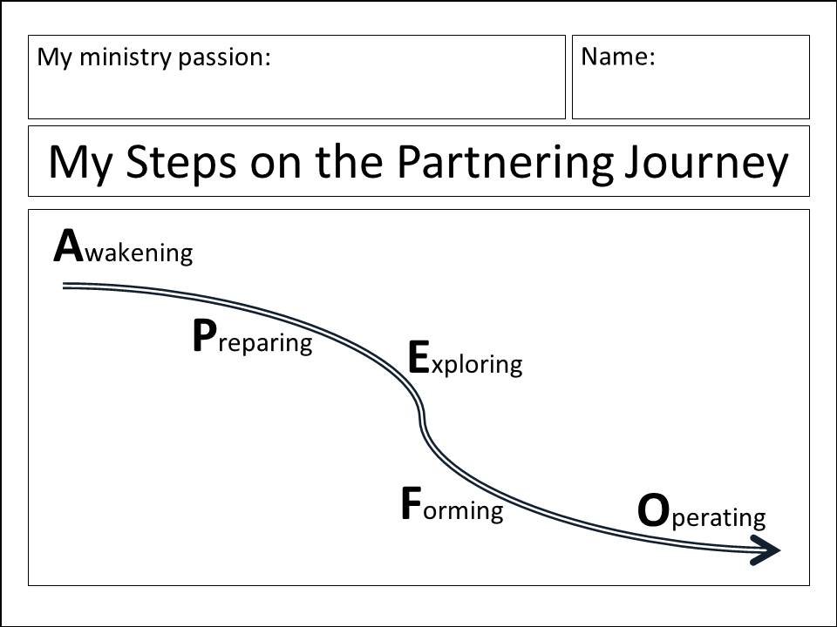
EXERCISE 22b:
Suggested questions to ask one another about your proposed personal action steps
Do you have the capacity to do these actions steps?

How confident are you about actually doing them?

How committed are you to carry through and do them? Which ones will be easiest? hardest?

How realistic are they – in the light of your other commitments, your energy, your resources?

Who else could you ask to help you to carry out these action steps?

To the consultant: Feel free to offer other feedback you may have to help strengthen these personal action steps.

JOURNALING EXERCISE
Who do you need to talk with back home about your milestones and personal action steps?

Describe what you will need to do to follow through on your commitment to carry through on your action steps. Which be the hardest to accomplish? Which will be easiest?

Where will you find the time to do these?

Session 23: The Partnering Journey: Continuing On

EXERCISE 23a:
List here the Kingdom Qualities that you would like to grow in:

