An Indigenous Mission Organization
FLOOD RELIEF UPDATE (XVII)
30 September 2017
Dear Partner in Ministry,

We are thankful and grateful to all our prayer partners, well wishers and donors for praying and helping us in time of flood crisis in 10 districts of West Bengal during July-August 2017. We did our best to reach out to the flood affected poor families, widows/women, and to the poor children. We could feed 1000 children, give clothes to the 300 poor widows/women, provide food grains (rice, wheat flower, cooking oil, soya bin, detergent, soap, bread etc) to 100 poor and needy families and some cash donation to help 50 farmers to restore cultivation. Every place we could share the love of Jesus Christ. Some of the poor elderly neglected widows appreciated us so much and they blessed us. The relief program opened many doors for us in the community including among the Muslims. Thank you once again for your financial help. Praise be to God.
Further Needs:
As we wrote earlier that our 20 children education centers are totally damaged by flood and we need to repair and rebuild these centers immediately for continuing with children education. During flood we continuously visited all our 600 children and their families. We are planning for medical camps for health check up and to provide some medicine to the children and sick people. We also identified 50 of our children’s families that they need to make toilets, bathroom and kitchen that were destroyed by flood. We want to help these families too. We want to continue with food for the children and poor old widows.
Few selected photographs of Manna Mission outreach to the flood victims
Feeding Children and Widows
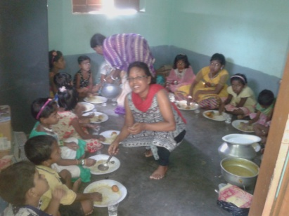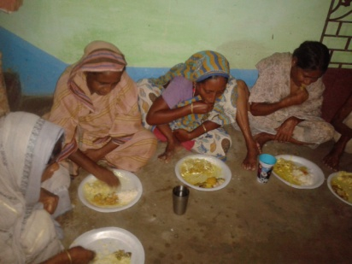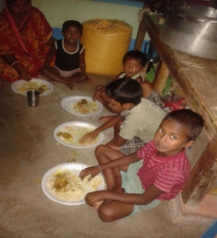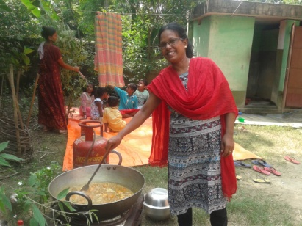
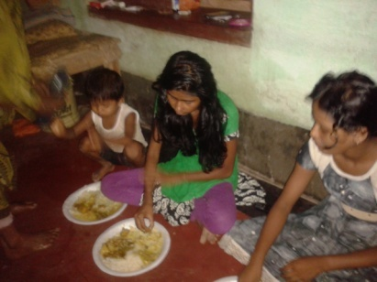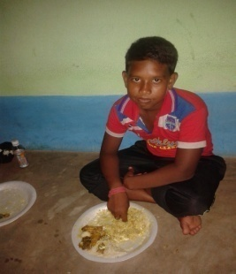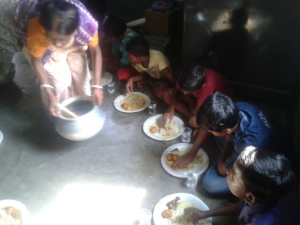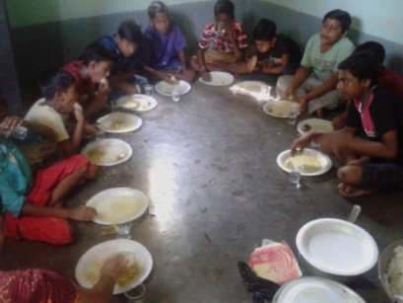

Reaching out to the Muslim Community
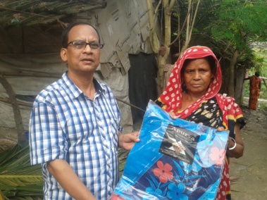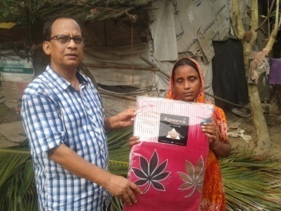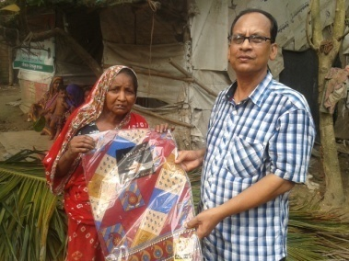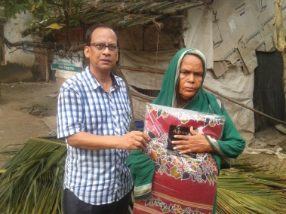
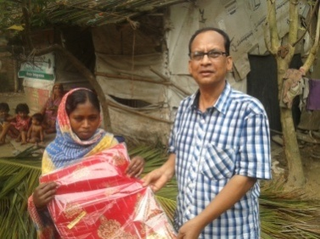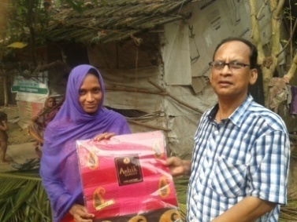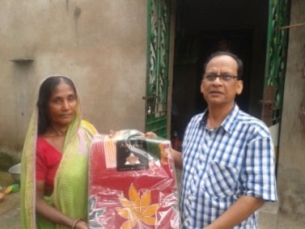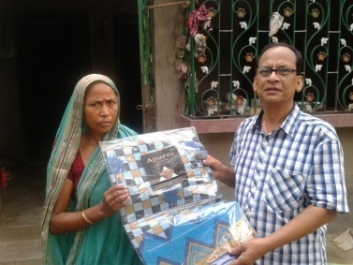

Distribution of Rice and other items
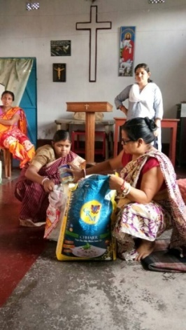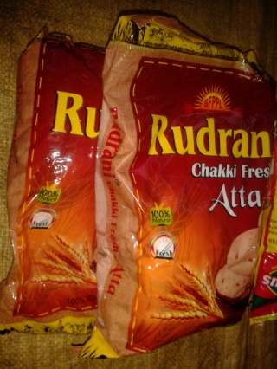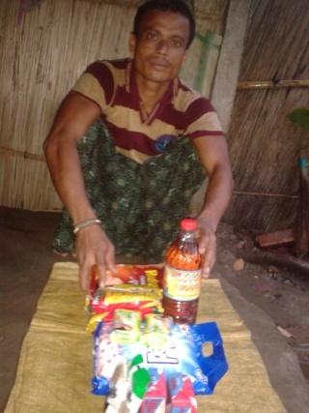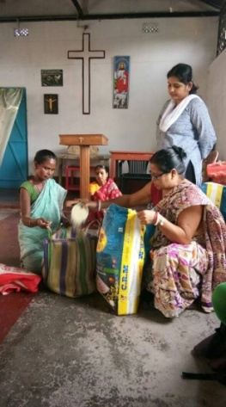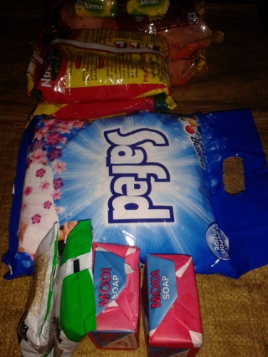
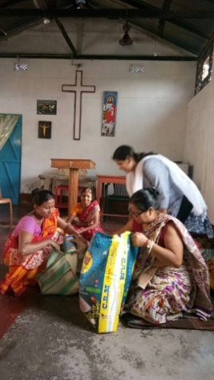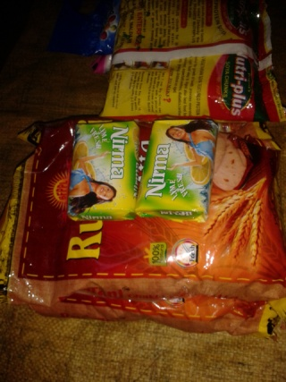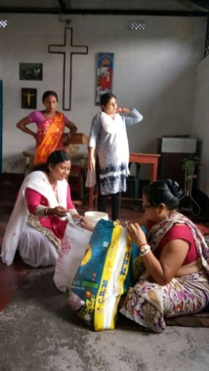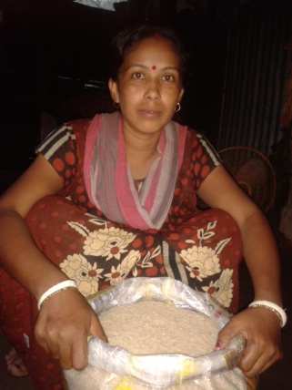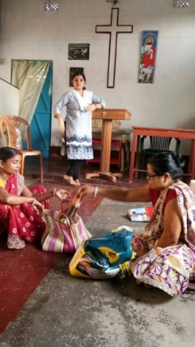
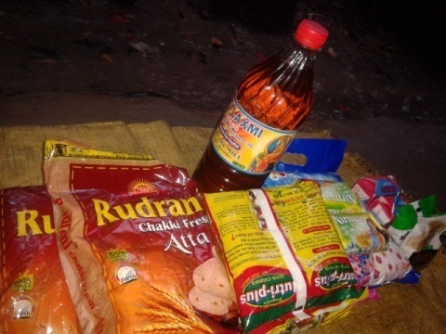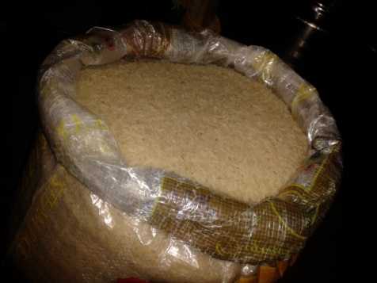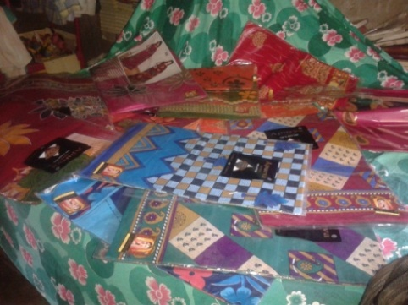
Distribution of clothes to Widows and poor women
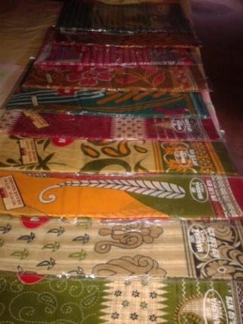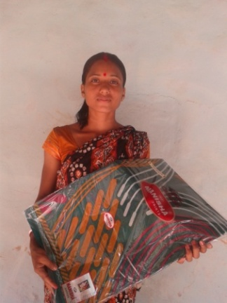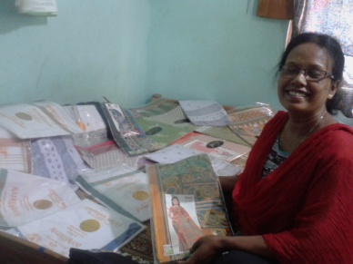
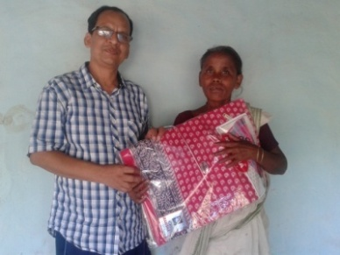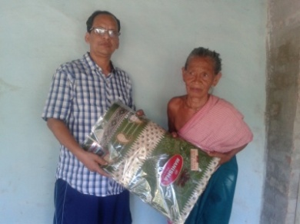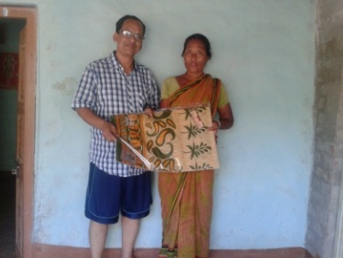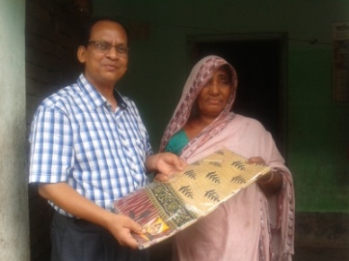
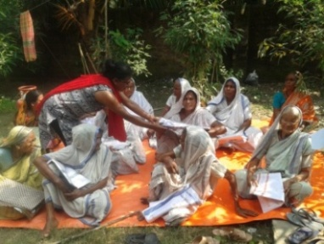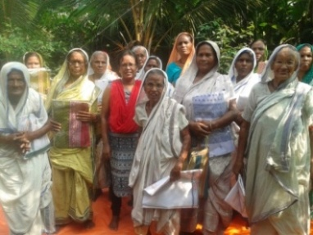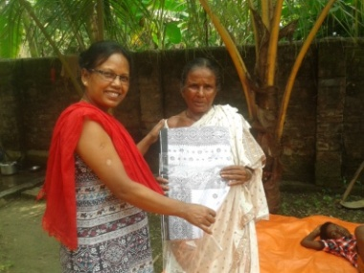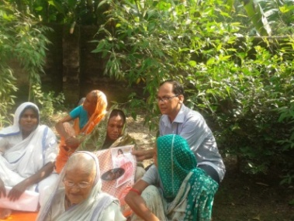
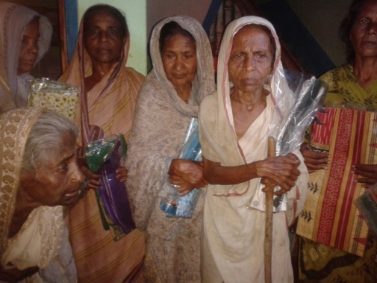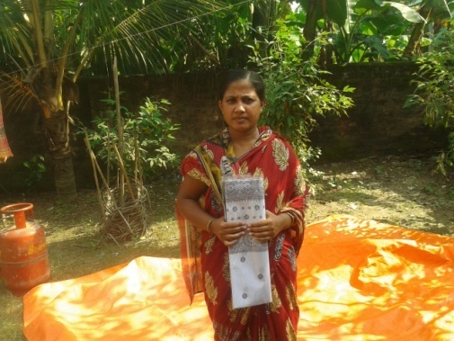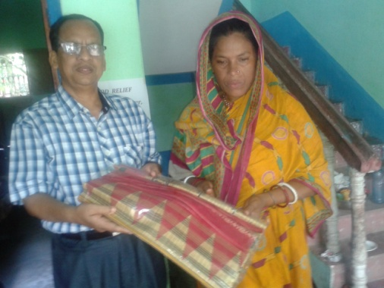

Thank you for your prayer for Manna Mission ministries and helping us in the time of flood crisis. Please continue to pray for our ministry to the children and widows. If God leads you to help us for any area of our ministry you can just send an email to us or call us. Thanking you all.

Rev. Tushar Manna
President, Manna Mission
West Bengal, India
Mobile: 0091 7686836119

